To whomsoever it may concern,

After viewing the dataset provided by Sprocket Central Pty Ltd, I have found some data inconsistencies and irrelevancies which I will explain in detail below. After cleaning the data and removing the inconsistencies, I ran it through Python to develop some data trends which might prove useful to Sprocket.

The issues which caught my attention in the dataset were lack of:

* Consistency: Some gender entries were incomplete/inaccurate with numerous customers being gendered “U” instead of Female of Male. Some gender fields were marked with just “M” or “F”.
* Completeness: A column named “Default” had erroneous values like “&84757”, which do not contain any information about the customer and can be deleted.
* Relevancy: On their dataset, there are 2 customers with DOBs in early 1930s and 1 customer with DOB in 1831. This suggests their Customer Demographic Dataset needs to be updated in order to reflect their active customer demographic, which would help them make effective business decisions.

After cleaning through the data, I have segregated the customer database into three categories which will benefit Sprocket in understanding their consumer base better

**Cumulative Bike sales vs Gender of Customer**

Icon: 1) **F’s P** -> Female Purchases

2) **M’s P** -> Male Purchases

3) **U’s P** -> “Unknown” Purchases (Gender not defined in database)

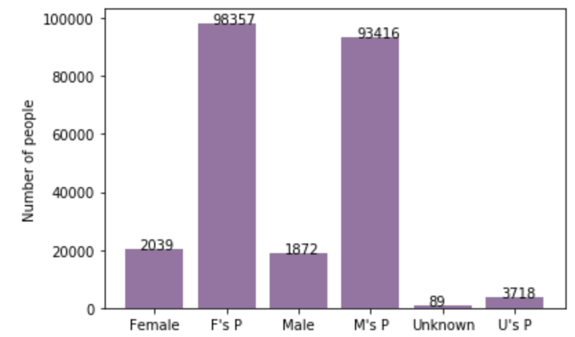

**Cumulative Bike sales vs Age of Customer**

Age (Mean): 43 Age (Standard Deviation): 13

Icon: q1: age <= (mean – standard deviation/2)

q2: (mean – standard deviation/2) < age <= mean

q3: mean < age <= (mean + standard deviation/2)

q4: (mean + standard deviation/2) < age

f: female m: male

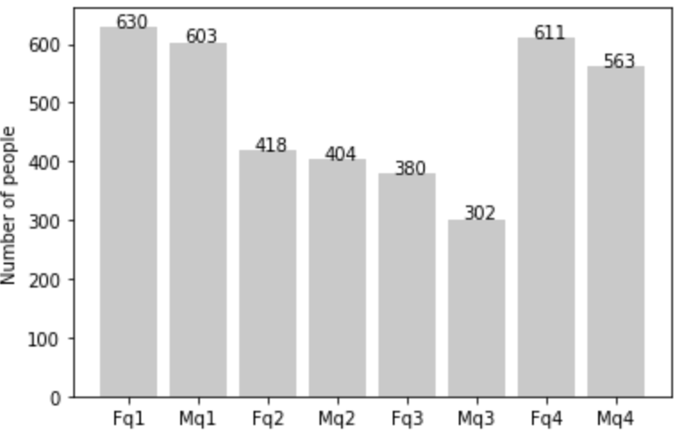

**Age of Customers vs Wealth Segment**

Icon: q1: age <= (mean – standard deviation/2)

q2: (mean – standard deviation/2) < age <= mean

q3: mean < age <= (mean + standard deviation/2)

q4: (mean + standard deviation/2) < age

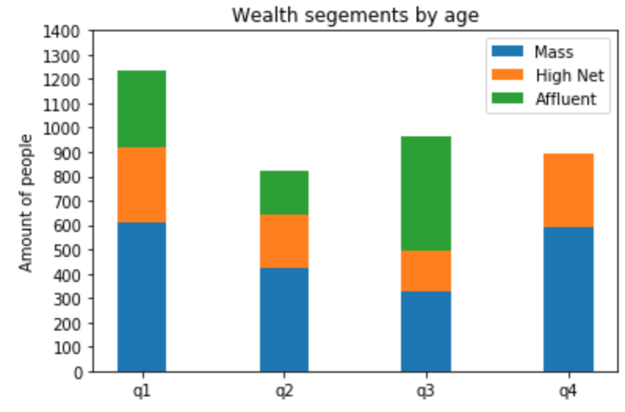

**Bike Sales vs Occupation of Customers**

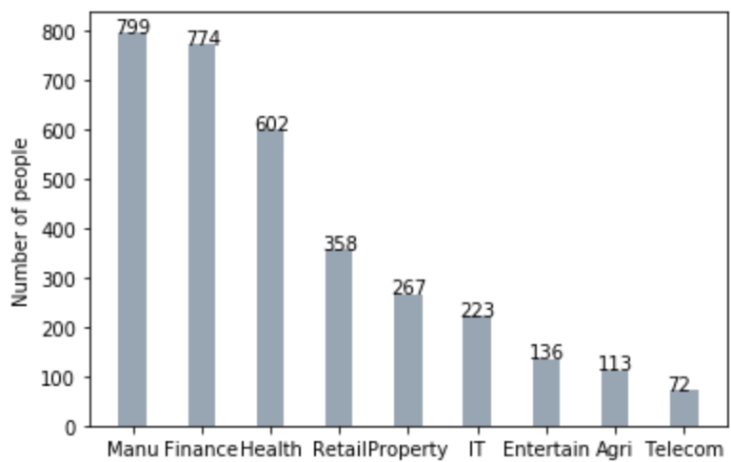

Sincerely,

Arkajit Dutta